**Exercise 2: Implementing Dependency Injection**

**Pom.xml:**

<project xmlns="http://maven.apache.org/POM/4.0.0" xmlns:xsi="http://www.w3.org/2001/XMLSchema-instance"

xsi:schemaLocation="http://maven.apache.org/POM/4.0.0 http://maven.apache.org/xsd/maven-4.0.0.xsd">

<modelVersion>4.0.0</modelVersion>

<groupId>org.example</groupId>

<artifactId>LibraryManagement</artifactId>

<version>1.0-SNAPSHOT</version>

<packaging>jar</packaging>

<name>LibraryManagement</name>

<url>http://maven.apache.org</url>

<properties>

<project.build.sourceEncoding>UTF-8</project.build.sourceEncoding>

</properties>

<dependencies>

<dependency>

<groupId>junit</groupId>

<artifactId>junit</artifactId>

<version>3.8.1</version>

<scope>test</scope>

</dependency>

<!-- Spring Context -->

<dependency>

<groupId>org.springframework</groupId>

<artifactId>spring-context</artifactId>

<version>5.3.33</version>

</dependency>

</dependencies>

</project>

**applicationContent.xml**

<!-- applicationContext.xml -->

<beans xmlns="http://www.springframework.org/schema/beans"

xmlns:xsi="http://www.w3.org/2001/XMLSchema-instance"

xsi:schemaLocation="

http://www.springframework.org/schema/beans

http://www.springframework.org/schema/beans/spring-beans.xsd">

<!-- BookRepository Bean -->

<bean id="bookRepository" class="org.example.BookRepository" />

<!-- BookService Bean -->

<bean id="bookService" class="org.example.BookService">

<property name="bookRepository" ref="bookRepository" />

</bean>

</beans>

**BookRepository.java**

package org.example;

public class BookRepository {

public void listBooks() {

System.out.println("Listing all books...");

}

}

**BookService.java**

package org.example;

import org.example.BookRepository;

public class BookService {

private BookRepository bookRepository;

// Setter for Dependency Injection

public void setBookRepository(BookRepository bookRepository) {

this.bookRepository = bookRepository;

}

public void displayBooks() {

bookRepository.listBooks();

}

}

**App.java**

package org.example;

import org.example.BookService;

import org.springframework.context.ApplicationContext;

import org.springframework.context.support.ClassPathXmlApplicationContext;

public class App

{

public static void main(String[] args) {

ApplicationContext context =

new ClassPathXmlApplicationContext("applicationContext.xml");

BookService bookService = (BookService) context.getBean("bookService");

bookService.displayBooks();

}

}

**OUTPUT:**

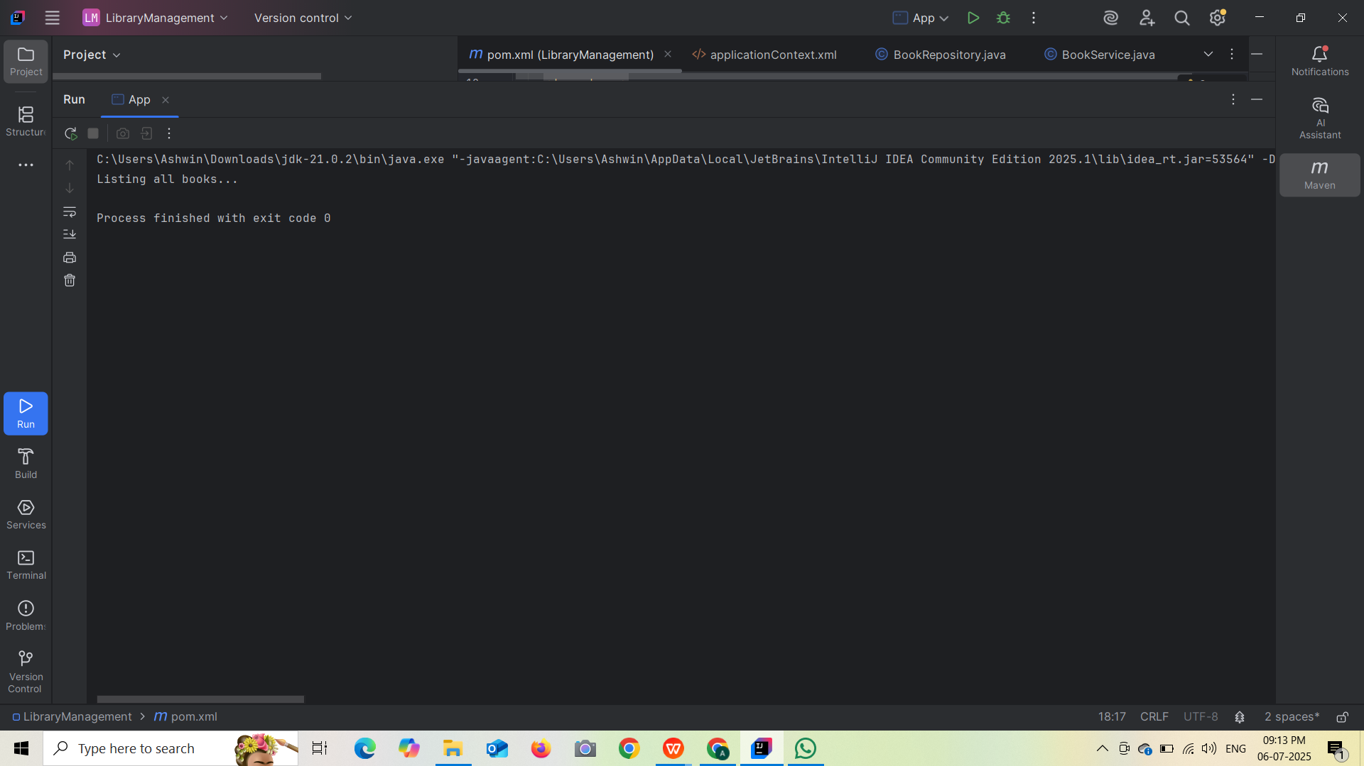

**Exercise 1: Configuring a Basic Spring Application**

**Pom.xml:**

<project xmlns="http://maven.apache.org/POM/4.0.0" xmlns:xsi="http://www.w3.org/2001/XMLSchema-instance"

xsi:schemaLocation="http://maven.apache.org/POM/4.0.0 http://maven.apache.org/xsd/maven-4.0.0.xsd">

<modelVersion>4.0.0</modelVersion>

<groupId>org.example</groupId>

<artifactId>LibraryManagement</artifactId>

<version>1.0-SNAPSHOT</version>

<packaging>jar</packaging>

<name>LibraryManagement</name>

<url>http://maven.apache.org</url>

<properties>

<project.build.sourceEncoding>UTF-8</project.build.sourceEncoding>

</properties>

<dependencies>

<dependency>

<groupId>junit</groupId>

<artifactId>junit</artifactId>

<version>3.8.1</version>

<scope>test</scope>

</dependency>

<!-- Spring Context -->

<dependency>

<groupId>org.springframework</groupId>

<artifactId>spring-context</artifactId>

<version>5.3.33</version>

</dependency>

</dependencies>

</project>

**applicationContent.xml**

<?xml version="1.0" encoding="UTF-8"?>

<beans xmlns="http://www.springframework.org/schema/beans"

xmlns:xsi="http://www.w3.org/2001/XMLSchema-instance"

xsi:schemaLocation="http://www.springframework.org/schema/beans

http://www.springframework.org/schema/beans/spring-beans.xsd">

<!-- Define Repository Bean -->

<bean id="bookRepository" class="org.example.BookRepository" />

<!-- Define Service Bean with dependency injection -->

<bean id="bookService" class="org.example.BookService">

<property name="bookRepository" ref="bookRepository"/>

</bean>

</beans>

**BookRepository.java**

package org.example;

public class BookRepository {

public void saveBook(String bookName) {

System.out.println("Saving book: " + bookName);

}

}

**BookService.java**

package org.example;

import org.example.BookRepository;

public class BookService {

private BookRepository bookRepository;

// Setter for dependency injection

public void setBookRepository(BookRepository bookRepository) {

this.bookRepository = bookRepository;

}

public void addBook(String bookName) {

System.out.println("Adding book: " + bookName);

bookRepository.saveBook(bookName);

}

}

**App.java**

package org.example;

import org.example.BookService;

import org.springframework.context.ApplicationContext;

import org.springframework.context.support.ClassPathXmlApplicationContext;

public class App

{

public static void main(String[] args) {

// Load Spring container

ApplicationContext context = new ClassPathXmlApplicationContext("applicationContext.xml");

// Get bookService bean and call method

BookService bookService = context.getBean("bookService", BookService.class);

bookService.addBook("Spring in Action");

}

}

**OUTPUT:**

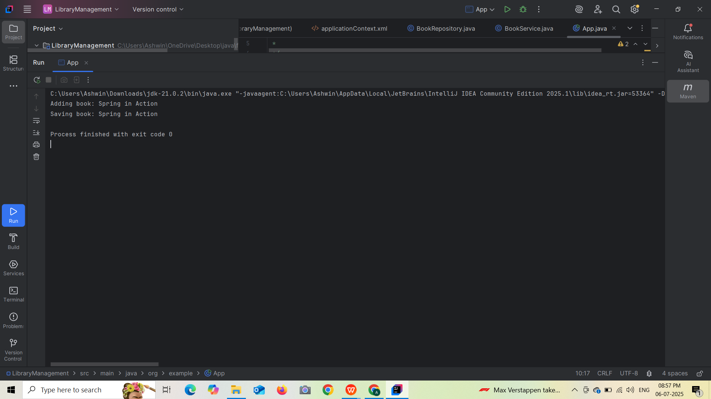

**Exercise 5: Configuring the Spring IoC Container**

**pom.xml:**

<project xmlns="http://maven.apache.org/POM/4.0.0" xmlns:xsi="http://www.w3.org/2001/XMLSchema-instance"

xsi:schemaLocation="http://maven.apache.org/POM/4.0.0 http://maven.apache.org/xsd/maven-4.0.0.xsd">

<modelVersion>4.0.0</modelVersion>

<groupId>org.example</groupId>

<artifactId>LibraryManagement</artifactId>

<version>1.0-SNAPSHOT</version>

<packaging>jar</packaging>

<name>LibraryManagement</name>

<url>http://maven.apache.org</url>

<properties>

<project.build.sourceEncoding>UTF-8</project.build.sourceEncoding>

</properties>

<dependencies>

<dependency>

<groupId>junit</groupId>

<artifactId>junit</artifactId>

<version>3.8.1</version>

<scope>test</scope>

</dependency>

<!-- Spring Context -->

<dependency>

<groupId>org.springframework</groupId>

<artifactId>spring-context</artifactId>

<version>5.3.33</version>

</dependency>

</dependencies>

</project>

**applicationContent.xml:**

<?xml version="1.0" encoding="UTF-8"?>

<beans xmlns="http://www.springframework.org/schema/beans"

xmlns:xsi="http://www.w3.org/2001/XMLSchema-instance"

xsi:schemaLocation="

http://www.springframework.org/schema/beans

http://www.springframework.org/schema/beans/spring-beans.xsd">

<!-- Define BookRepository Bean -->

<bean id="bookRepository" class="org.example.BookRepository" />

<!-- Define BookService Bean and inject BookRepository -->

<bean id="bookService" class="org.example.BookService">

<property name="bookRepository" ref="bookRepository"/>

</bean>

</beans>

**BookRepository.java:**

package org.example;

public class BookRepository {

public void saveBook(String title) {

System.out.println("Saving book: " + title);

}

}

**BookService.java:**

package org.example;

import org.example.BookRepository;

public class BookService{

private BookRepository bookRepository;

// Setter for DI

public void setBookRepository(BookRepository bookRepository) {

this.bookRepository = bookRepository;

}

public void addBook(String title) {

System.out.println("Adding book: " + title);

bookRepository.saveBook(title);

}

}

**App.java:**

package org.example;

import org.springframework.context.ApplicationContext;

import org.springframework.context.support.ClassPathXmlApplicationContext;

public class App

{

public static void main(String[] args) {

ApplicationContext context = new ClassPathXmlApplicationContext("applicationContext.xml");

BookService bookService = (BookService) context.getBean("bookService");

bookService.addBook("Java for Beginners");

}

}

**OUTPUT:**

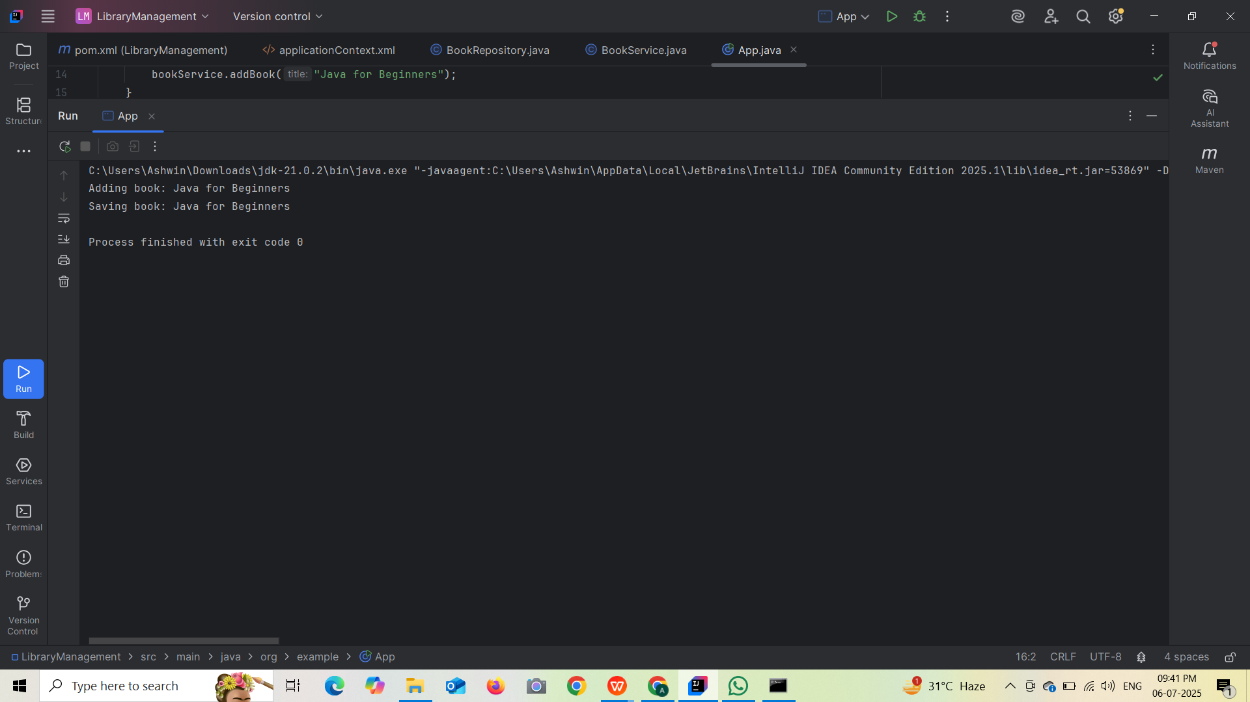

**Exercise 7: Implementing Constructor and Setter Injection**

**pom.xml:**

<project xmlns="http://maven.apache.org/POM/4.0.0" xmlns:xsi="http://www.w3.org/2001/XMLSchema-instance"

xsi:schemaLocation="http://maven.apache.org/POM/4.0.0 http://maven.apache.org/xsd/maven-4.0.0.xsd">

<modelVersion>4.0.0</modelVersion>

<groupId>org.example</groupId>

<artifactId>LibraryManagement</artifactId>

<version>1.0-SNAPSHOT</version>

<packaging>jar</packaging>

<name>LibraryManagement</name>

<url>http://maven.apache.org</url>

<properties>

<project.build.sourceEncoding>UTF-8</project.build.sourceEncoding>

</properties>

<dependencies>

<dependency>

<groupId>junit</groupId>

<artifactId>junit</artifactId>

<version>3.8.1</version>

<scope>test</scope>

</dependency>

<!-- Spring Context -->

<dependency>

<groupId>org.springframework</groupId>

<artifactId>spring-context</artifactId>

<version>5.3.33</version>

</dependency>

</dependencies>

</project>

**applicationContent.xml:**

<?xml version="1.0" encoding="UTF-8"?>

<beans xmlns="http://www.springframework.org/schema/beans"

xmlns:xsi="http://www.w3.org/2001/XMLSchema-instance"

xsi:schemaLocation="

http://www.springframework.org/schema/beans

http://www.springframework.org/schema/beans/spring-beans.xsd">

<!-- BookRepository Bean -->

<bean id="bookRepository" class="org.example.BookRepository" />

<!-- BookService Bean using both constructor and setter injection -->

<bean id="bookService" class="org.example.BookService">

<!-- Constructor Injection -->

<constructor-arg value="Madurai Public Library"/>

<!-- Setter Injection -->

<property name="bookRepository" ref="bookRepository"/>

</bean>

</beans>

**BookRepository.java**

package org.example;

public class BookRepository {

public void saveBook(String title) {

System.out.println("Saving book: " + title);

}

}

**BookService.java**

package org.example;

public class BookService {

private final String libraryName; // Constructor injected

private BookRepository bookRepository; // Setter injected

// Constructor

public BookService(String libraryName) {

this.libraryName = libraryName;

}

// Setter for DI

public void setBookRepository(BookRepository bookRepository) {

this.bookRepository = bookRepository;

}

public void addBook(String title) {

System.out.println("[" + libraryName + "] Adding book: " + title);

bookRepository.saveBook(title);

}

}

**App.java**

package org.example;

import org.springframework.context.ApplicationContext;

import org.springframework.context.support.ClassPathXmlApplicationContext;

public class App

{

public static void main(String[] args) {

ApplicationContext context = new ClassPathXmlApplicationContext("applicationContext.xml");

BookService bookService = (BookService) context.getBean("bookService");

bookService.addBook("Spring in Action");

}

}

**OUTPUT:**

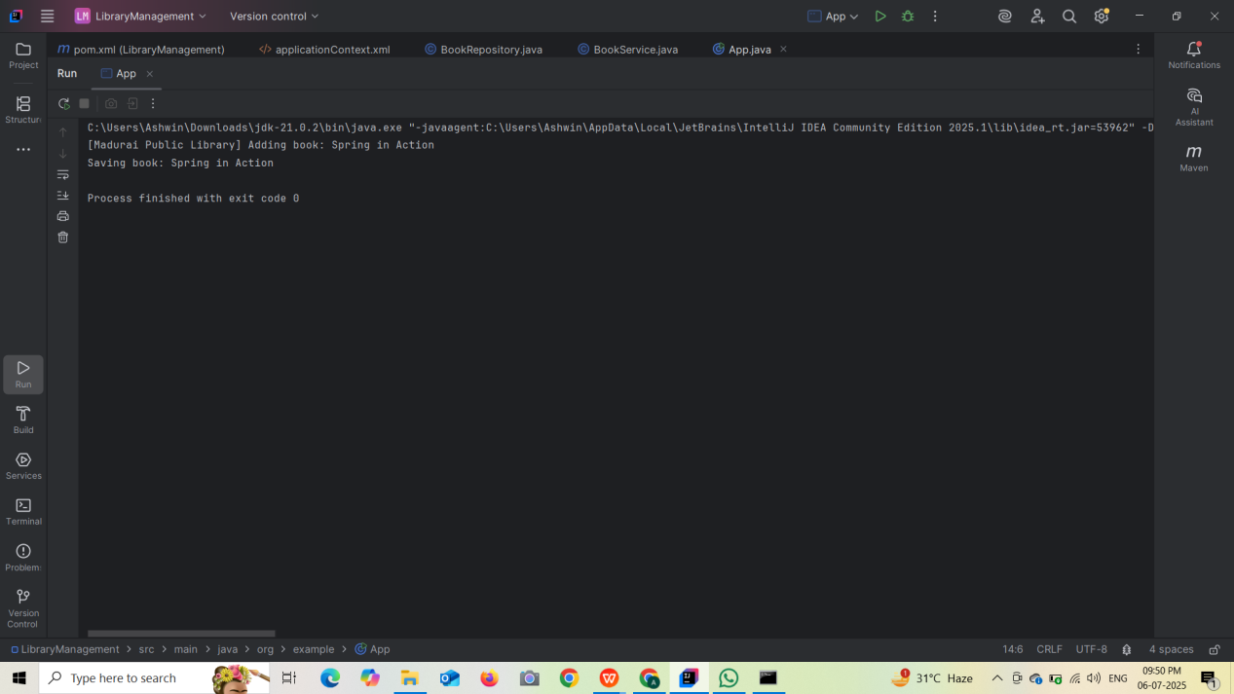

**Exercise 4: Creating and Configuring a Maven Project**

**pom.xml(LibraryManagement):**

<project xmlns="http://maven.apache.org/POM/4.0.0" xmlns:xsi="http://www.w3.org/2001/XMLSchema-instance"

xsi:schemaLocation="http://maven.apache.org/POM/4.0.0 http://maven.apache.org/xsd/maven-4.0.0.xsd">

<modelVersion>4.0.0</modelVersion>

<groupId>org.example</groupId>

<artifactId>LibraryManagement</artifactId>

<version>1.0-SNAPSHOT</version>

<packaging>jar</packaging>

<name>LibraryManagement</name>

<url>http://maven.apache.org</url>

<properties>

<project.build.sourceEncoding>UTF-8</project.build.sourceEncoding>

</properties>

<dependencies>

<!-- Spring Context -->

<dependency>

<groupId>org.springframework</groupId>

<artifactId>spring-context</artifactId>

<version>5.3.32</version>

</dependency>

<dependency>

<groupId>junit</groupId>

<artifactId>junit</artifactId>

<version>4.13.2</version>

<scope>test</scope>

</dependency>

<!-- Spring AOP -->

<dependency>

<groupId>org.springframework</groupId>

<artifactId>spring-aop</artifactId>

<version>5.3.32</version>

</dependency>

<!-- Spring Web MVC -->

<dependency>

<groupId>org.springframework</groupId>

<artifactId>spring-webmvc</artifactId>

<version>5.3.32</version>

</dependency>

<!-- Optional: Servlet API (for Web MVC) -->

<dependency>

<groupId>javax.servlet</groupId>

<artifactId>javax.servlet-api</artifactId>

<version>4.0.1</version>

<scope>provided</scope>

</dependency>

</dependencies>

<build>

<plugins>

<!-- Compiler Plugin -->

<plugin>

<groupId>org.apache.maven.plugins</groupId>

<artifactId>maven-compiler-plugin</artifactId>

<version>3.8.1</version>

<configuration>

<source>1.8</source>

<target>1.8</target>

</configuration>

</plugin>

</plugins>

</build>

</project>

**OUTPUT:**

